Answer 1
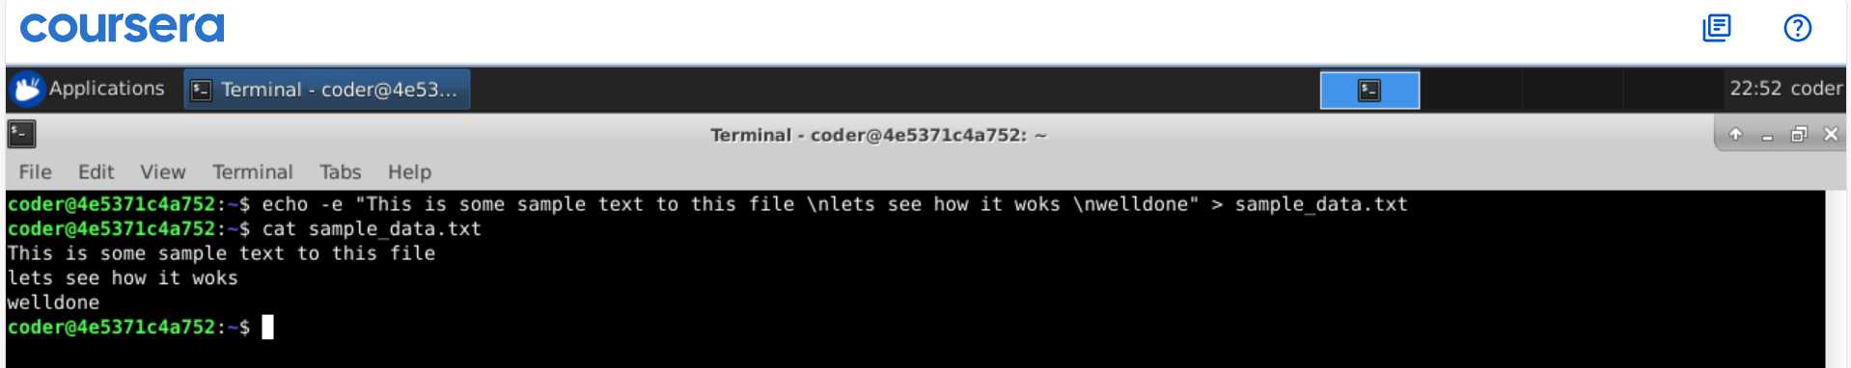
Explanation: By using echo command with -e option and > standard output to sample_data.txt we have achieved desired output in 1 line.
Answer 2
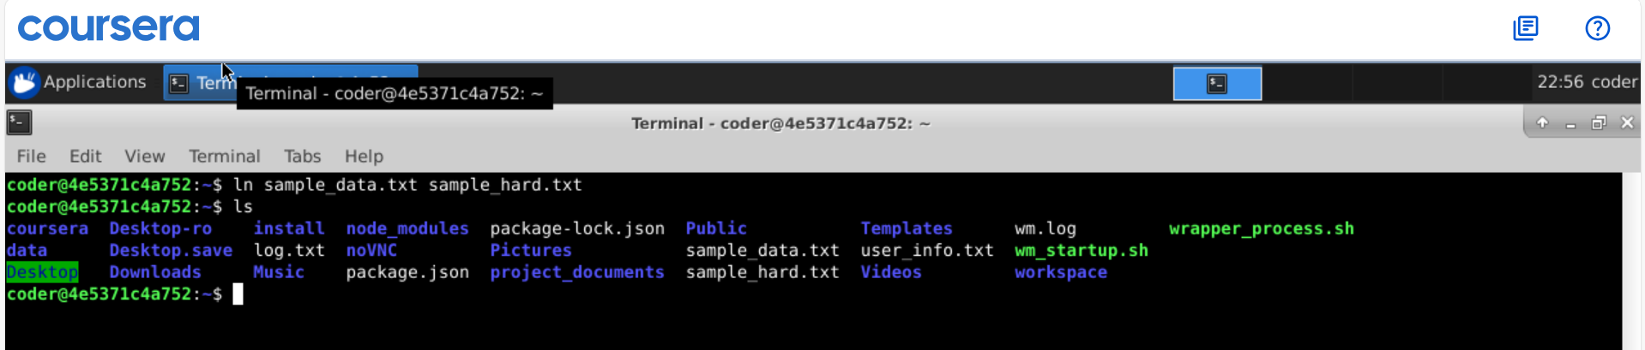
Explanation: By using ln command we get a hardlink as desires. It would by provide source file first and desired name for hardline next.
Answer 3
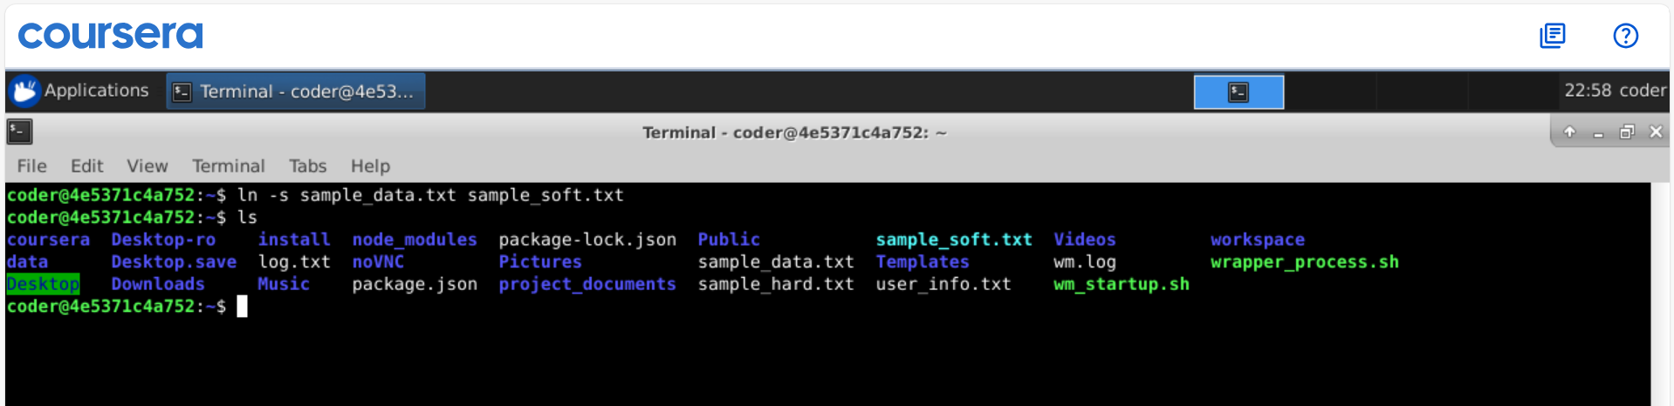
Explanation: By using ln command with -s option we can create a soft link. This has the same way provide source file first followed by the new name for the soft link.
Answer 4
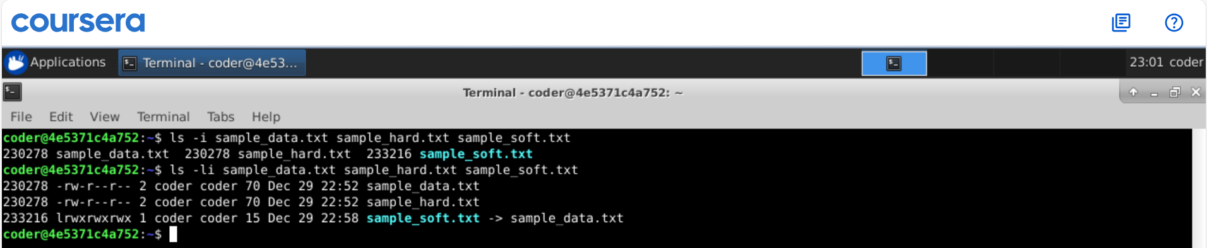
Explanation: Using ls command with -I option will show the Inode number. To use it followed by the file names if you want inode number for specific files. Also using -l option with I gives detailed view with permission and Inode number together.
Answer 5
Explanation: As seen Hard link of the source file shared the same Inode number, because when we create a hard link, it doesn’t create a new file instead it just creates a copy of the same Inode number. Deleting the source file will not leave the hard link dangling, instead hard link will help to keep the file accessible as it has same inode number .
Answer 6
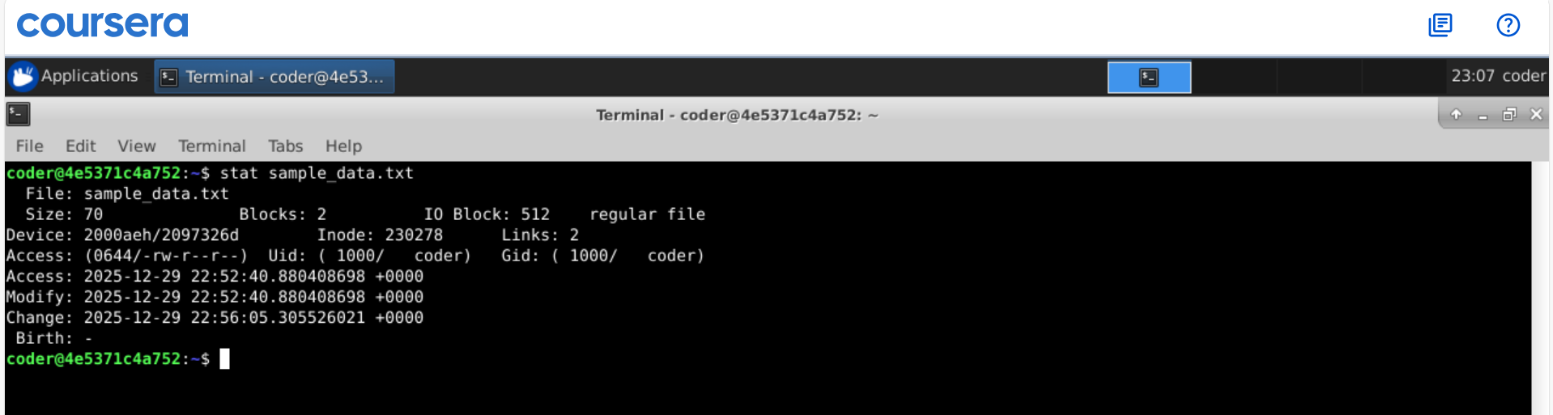
Explanation: Stat command followed by the file name gets us the all info about file with its creation date detailed file information (permissions, ownership, size, timestamps).
Answer 7
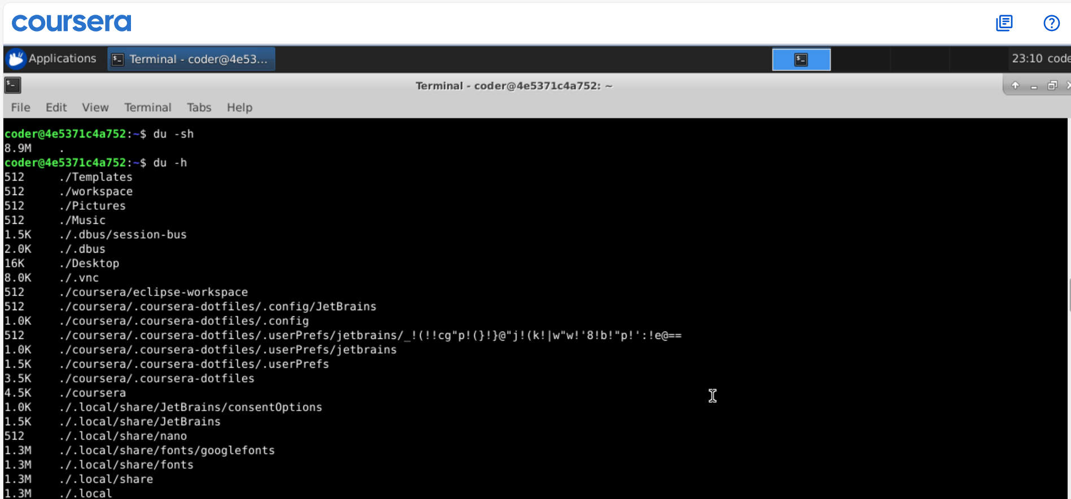
Explanation: As I am already in my home directory, we can use du command with -h option human readable size. Using -s option will show concise info adding all usage. If I am in any other directory I can add ~ at the end of the command.
Answer 8
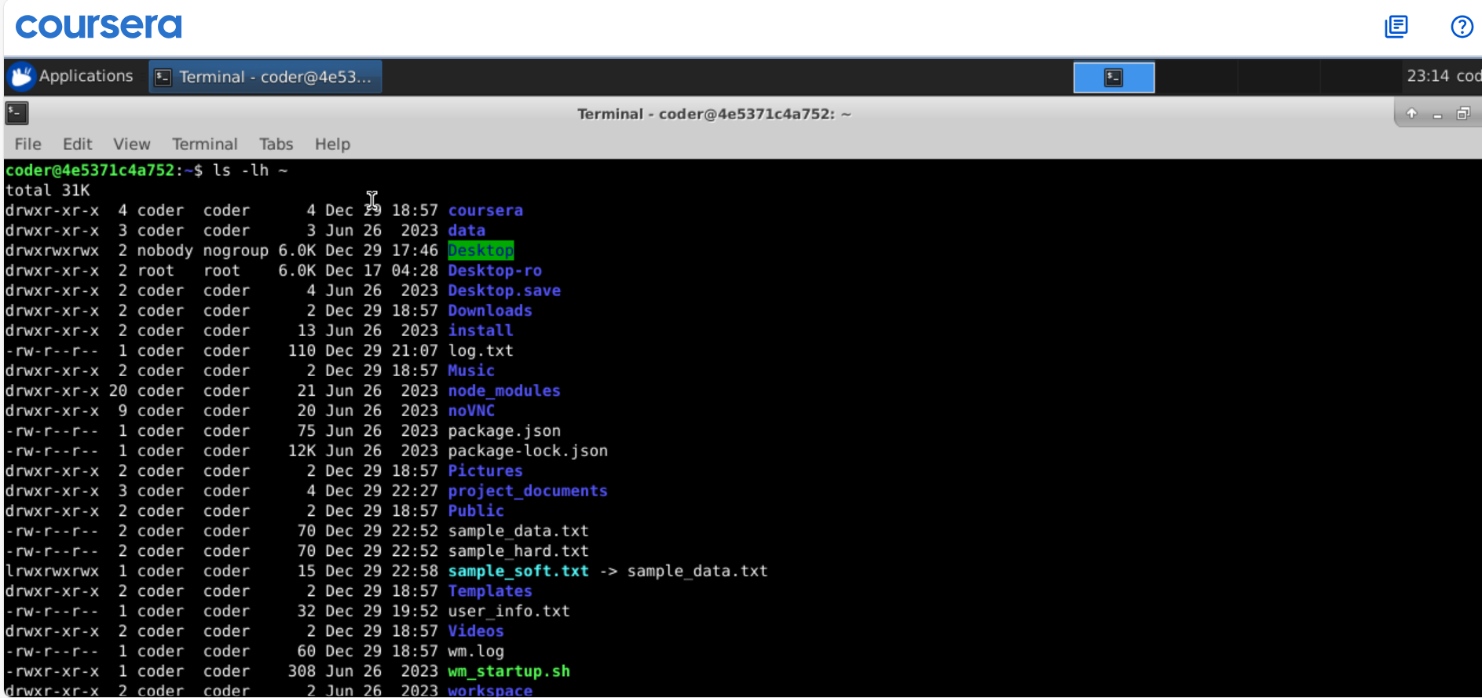
Explanation: using ls command with -lh option will show detailed view with human readable data size. In above some files which are really small or kind of empty shows in bytes as 4 or 2 etc.
Answer 9
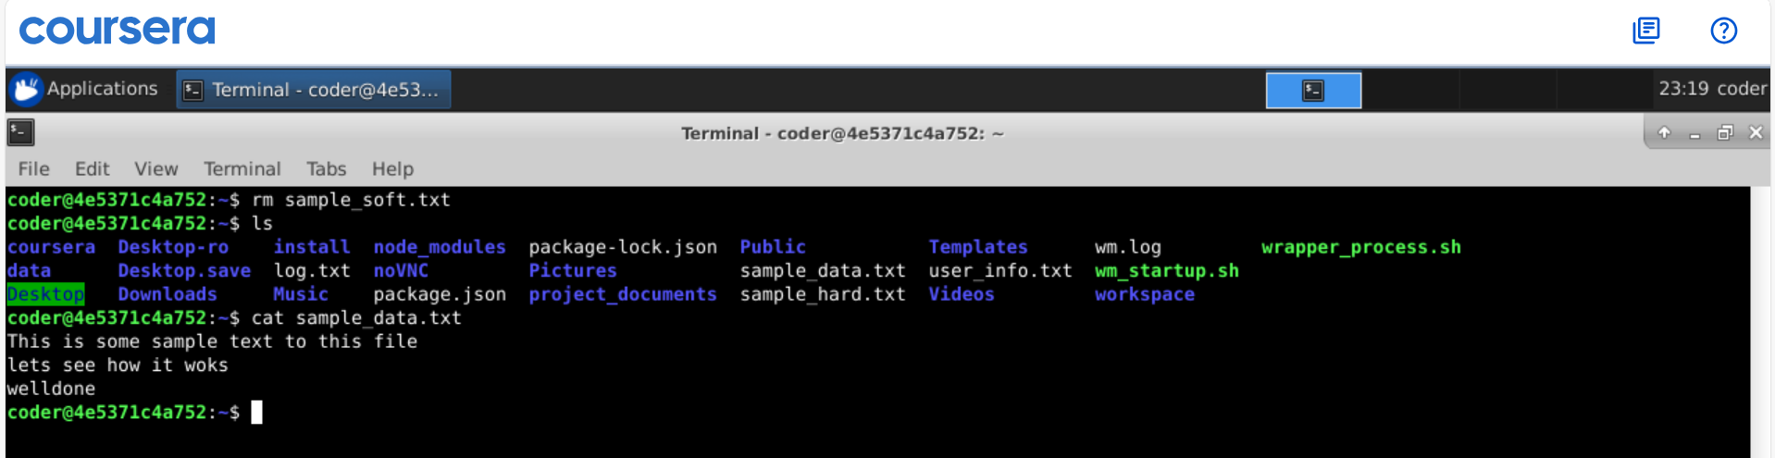
Explanation: By using rm command we can remove the file by removing soft link we have no changes to the original file as seen. We could also unlink the soft link and it will still won’t affect the original file. Though link will be dangling without source.

Answer 10
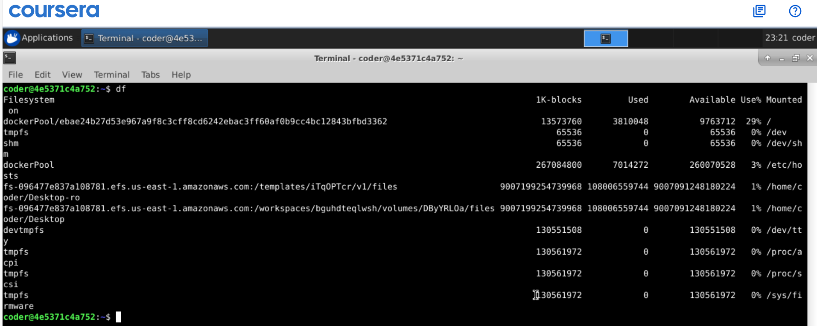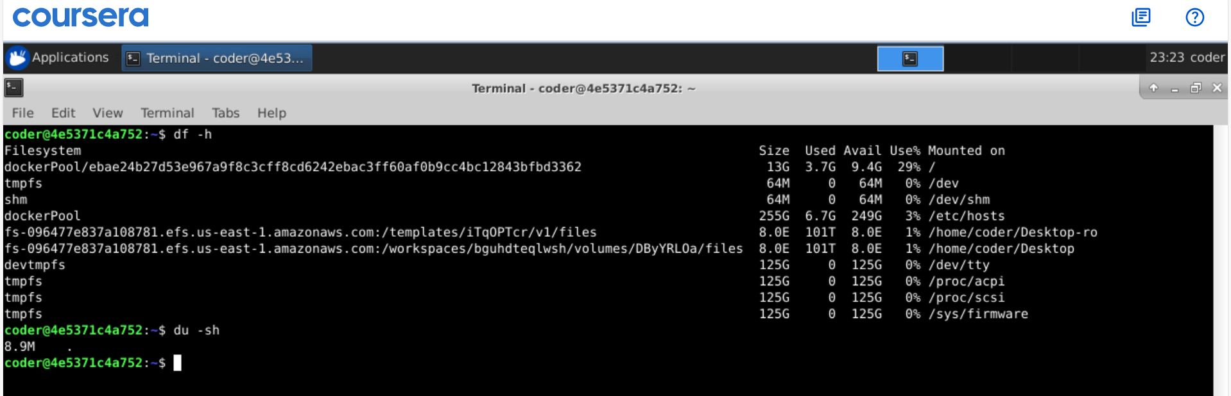
Explanation: du and df commands both are really helpful for check disk usage and free space available with filesystems. These command came with many option can be seen using --help option. In above I have used -h option for human readable size and -s option to the concise result added all sizes.

